

**Pricing List** 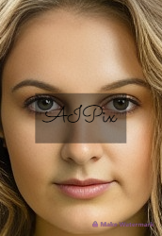

[*www.aipix.org.uk*](http://www.aipix.org.uk)Template  
[*info@aipix.org.uk*](mailto:info@aipix.org.uk)**Product/Service - Licenced Images. Self AI Image**

|  | **Product/Service Name** | **Description** | **Unit Price** |
| --- | --- | --- | --- |
|  |  |  |  |
|  |  |  |  |
|  | AI Self Image Template Package 1 | My AI image template to use for 1 Ad or 1 Marketing Campaign | £200 |
|  | AI Self Image Template Package 2 | My AI self-Image template to use in any Ad or Marketing Campaign for 6 months. | £500 |
|  | AI Self Image Template Package 3 | My AI self-Image template to use in any Ad or Marketing Campaign for 1 year | £750 |
|  |  |  |  |
|  | AI Self Image Template Package 4 | My AI self-Image template to use in any Ad or Marketing Campaign - LIFETIME | £1000 |
|  |  |  |  |
|  |

All pricing packages are subject to a written agreement which must be signed before release of the single AI self-image template. Packages 1-3 must be renewed after end date. Package 4 is a one-time fee.